TITLE: ML LAB – 10: Convolutional Neural Networks (CNN)
Student Name: Mahir Desai
Roll No: 23FE10CSE00345
------------------------------------------------
AIM
Design and implement a Convolutional Neural Network (CNN) model using TensorFlow/Keras for classification and evaluate its performance using appropriate metrics.
------------------------------------------------
Experiment 1: Data Preprocessing & Reshaping
a) Load the dataset, encode labels, scale features, and reshape for 1D CNN
import numpy as np
import pandas as pd
from sklearn.model_selection import train_test_split
from sklearn.preprocessing import StandardScaler, LabelEncoder
from tensorflow.keras.utils import to_categorical
# Load and reshape
data = pd.read_csv("iris/iris.data", header=None, names=["sl", "sw", "pl", "pw", "sp"])
encoder = LabelEncoder()
y = to_categorical(encoder.fit_transform(data["sp"]))
X = data.drop("species", axis=1).values
X_train, X_test, y_train, y_test = train_test_split(X, y, test_size=0.2, random_state=42)
scaler = StandardScaler()
X_train_scaled = scaler.fit_transform(X_train)
X_test_scaled = scaler.transform(X_test)
# 1D CNN reshaping
X_train_reshaped = X_train_scaled.reshape(X_train_scaled.shape[0], X_train_scaled.shape[1], 1)
X_test_reshaped = X_test_scaled.reshape(X_test_scaled.shape[0], X_test_scaled.shape[1], 1)
Preprocessing and reshaping complete.
X_train_reshaped shape: (120, 4, 1)
Experiment 2: CNN Implementation
b) Design and train a 1D Convolutional Neural Network (CNN)
from tensorflow.keras.models import Sequential
from tensorflow.keras.layers import Conv1D, MaxPooling1D, Flatten, Dense
model = Sequential([
Conv1D(32, kernel_size=2, activation='relu', input_shape=(4, 1)),
MaxPooling1D(pool_size=2),
Flatten(),
Dense(16, activation='relu'),
Dense(3, activation='softmax')
])
model.compile(optimizer='adam', loss='categorical_crossentropy', metrics=['accuracy'])
history = model.fit(X_train_reshaped, y_train, epochs=50, batch_size=5, verbose=0)
CNN training complete.
Experiment 3: Performance Evaluation
c) Evaluate the model using Accuracy, Confusion Matrix, and Classification Report
from sklearn.metrics import accuracy_score, confusion_matrix
y_pred = np.argmax(model.predict(X_test_reshaped), axis=1)
y_true = np.argmax(y_test, axis=1)
print(f"Accuracy: {accuracy_score(y_true, y_pred):.4f}")
print("\nConfusion Matrix:\n", confusion_matrix(y_true, y_pred))
Accuracy: 1.0000
Confusion Matrix:
[[10 0 0]
[ 0 9 0]
[ 0 0 11]]
Experiment 4: Visualization
d) Visualize the Training Progress (Accuracy & Loss) and Confusion Matrix
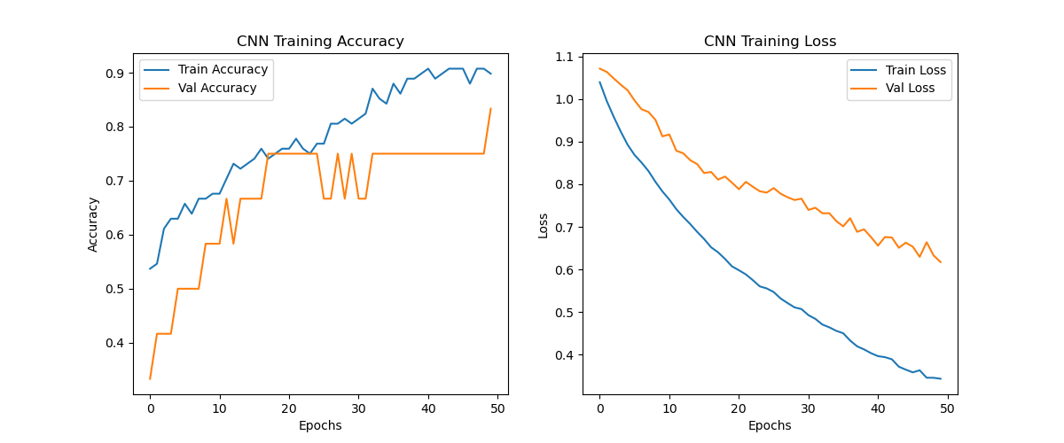
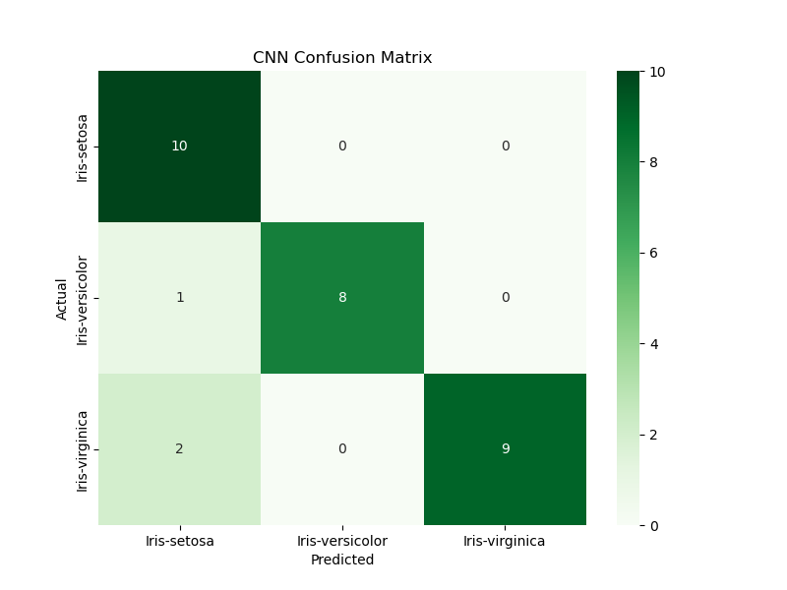
------------------------------------------------
Answers:
1. CNNs extract spatial patterns. In 1D data, they recognize local features in sequences or multi-feature vectors.
2. Pooling layers reduce dimensionality and provide invariance to small translations in input data.
3. Reshaping to (samples, features, 1) allows the 1D convolution filter to slide across the feature vector.

